

|  |
| --- |
| **FlyAway (An Airline Booking Portal)**  **(Project Specifications and Sprint Work)** |

**Version History:**

|  |  |
| --- | --- |
| Developer | Swathi Suheal J I |
| Purpose | Application Overview |
| Date | 7th October 2021 |
| Version | 1.0 |

## 

## Project Git Hub Link:

|  |
| --- |
| Repository Name: Phase |
| GIT HUB Link: https://github.com/SwathiJI/Phase2.git |

## General info

A small flight booking demo project in **JAVA**

## Using the application

Home displays the application name (FlyAway) and two options - Book Flights and Admin Panel Access

[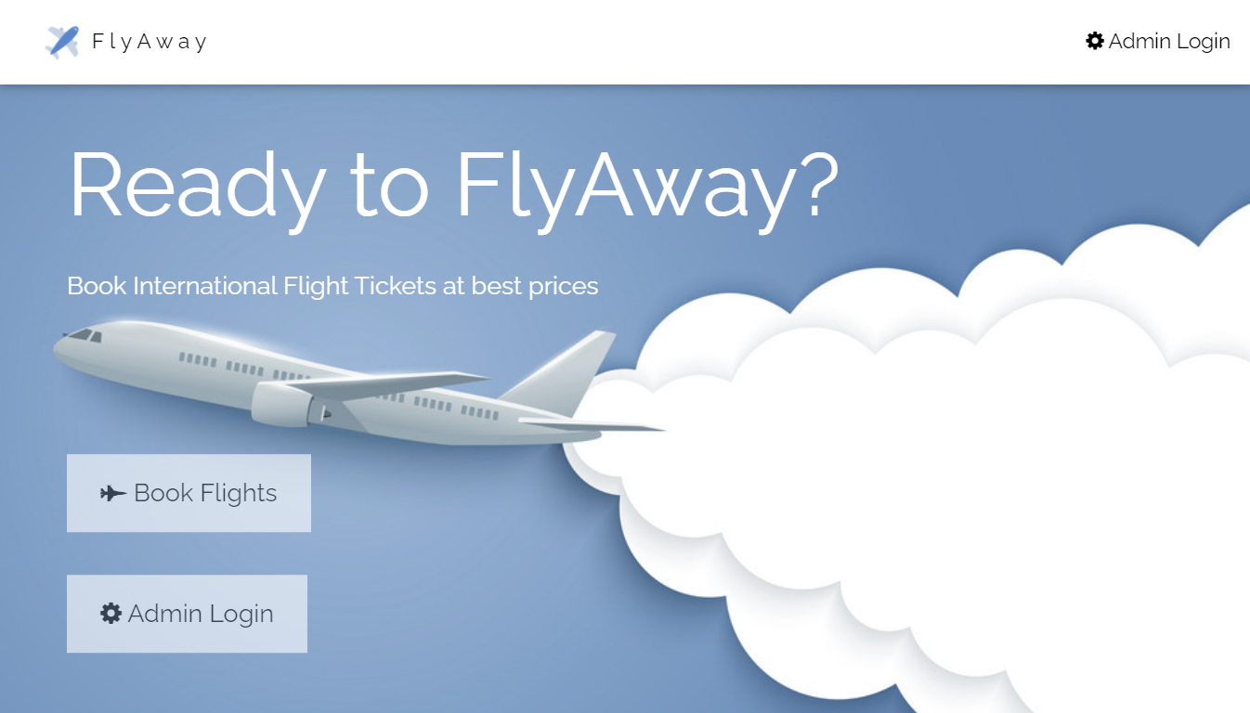](https://raw.githubusercontent.com/abhinov-gogoi/FlyAway2/main/screenshots/Homepage.png)

**Book Flights** -  
The user enters flight details (date, source, destination, travellers). A query is sent to the remote database to fetch related flights and displayed to user. The User enters other details and proceeds to book the flight.  
  
**Admin** -  
Admin dashboard is accessed with a preset username and password. Admin can see all entries in database table. Admin can change his password after Login

## Technologies

**Frontend** - JSP, HTML, CSS,

**Backend** - JAVA Servlets

**Database** - MySQL - Hosted on a remote server at AWS RDS

**Application Server** - Tomcat 10

## Setup

To run in your localhost - Clone into local and run project on tomcat server. If any issue check artifact is build properly.  
  
To deploy on a server use FlyAway.war file.